BGP Connecting OSPF and EIGRP

*Austin Tran-Struthers*

**

*Purpose*

To learn how to connect OSPF and EIGRP through BGP.

*Background*

BGP or border gateway protocol is an exterior gateway protocol that lets autonomous systems across the internet exchange routing information. It makes routing decisions based on paths, network policies or rules configured by a network admin. It was first described in 1989 and has been in use on the internet since 1994.

*Lab summary*

Using 6 routers to connect EIGRP and OSPF using BGP.

*Lab Commands*

**Router bgp** used to enter bgp configuration

**Ipv6 router bgp** used to configure bgp with ipv6

*Network Diagram*

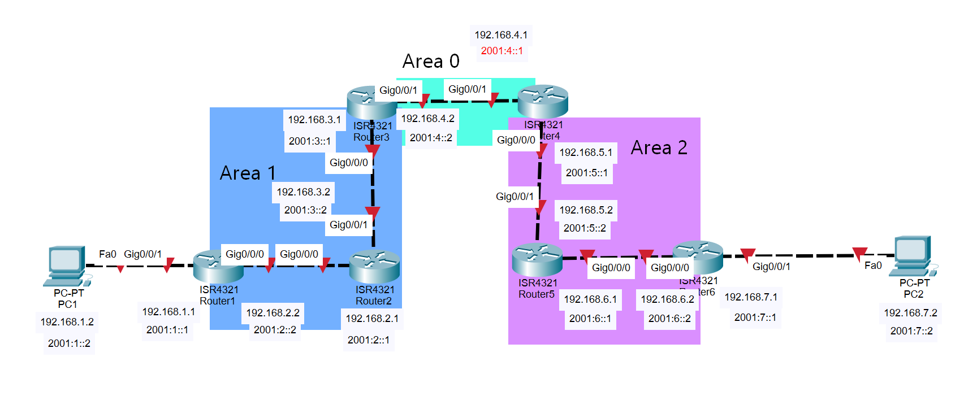

*Router Configurations*

*R1:*

*Last configuration change at 20:32:14 UTC Fri Oct 21 2022*

*version 15.5*

*service timestamps debug datetime msec*

*service timestamps log datetime msec*

*no platform punt-keepalive disable-kernel-core*

*hostname R1*

*boot-start-marker*

*boot-end-marker*

*vrf definition Mgmt-intf*

*address-family ipv4*

*exit-address-family*

*address-family ipv6*

*exit-address-family*

*no aaa new-model*

*ipv6 unicast-routing*

*subscriber templating*

*multilink bundle-name authenticated*

*license udi pid ISR4321/K9 sn FDO214811ZM*

*spanning-tree extend system-id*

*redundancy*

*mode none*

*vlan internal allocation policy ascending*

*interface GigabitEthernet0/0/0*

*ip address 192.168.2.2 255.255.255.0*

*negotiation auto*

*ipv6 address 2001:2::2/64*

*ipv6 ospf 1 area 0*

*interface GigabitEthernet0/0/1*

*ip address 192.168.1.1 255.255.255.0*

*negotiation auto*

*ipv6 address 2001:1::1/64*

*ipv6 ospf 1 area 0*

*interface Serial0/1/0*

*no ip address*

*shutdown*

*interface Serial0/1/1*

*no ip address*

*shutdown*

*interface GigabitEthernet0/2/0*

*no ip address*

*shutdown*

*negotiation auto*

*interface GigabitEthernet0/2/1*

*no ip address*

*shutdown*

*negotiation auto*

*interface GigabitEthernet0*

*vrf forwarding Mgmt-intf*

*no ip address*

*shutdown*

*negotiation auto*

*interface Vlan1*

*no ip address*

*shutdown*

*router ospf 1*

*router-id 1.1.1.1*

*network 192.168.1.0 0.0.0.255 area 0*

*network 192.168.2.0 0.0.0.255 area 0*

*ip forward-protocol nd*

*no ip http server*

*no ip http secure-server*

*ip tftp source-interface GigabitEthernet0*

*ipv6 router ospf 1*

*router-id 1.1.1.1*

*control-plane*

*line con 0*

*stopbits 1*

*line aux 0*

*stopbits 1*

*line vty 0 4*

*login*

*end*

*R2:*

Last configuration change at 20:57:28 UTC Fri Oct 21 2022

version 15.5

service timestamps debug datetime msec

service timestamps log datetime msec

no platform punt-keepalive disable-kernel-core

hostname R2

boot-start-marker

boot-end-marker

vrf definition Mgmt-intf

address-family ipv4

exit-address-family

address-family ipv6

exit-address-family

no aaa new-model

ipv6 unicast-routing

subscriber templating

multilink bundle-name authenticated

license udi pid ISR4321/K9 sn FDO214414TX

spanning-tree extend system-id

redundancy

mode none

vlan internal allocation policy ascending

interface GigabitEthernet0/0/0

ip address 192.168.2.1 255.255.255.0

negotiation auto

ipv6 address 2001:2::1/64

ipv6 ospf 1 area 0

interface GigabitEthernet0/0/1

ip address 192.168.3.2 255.255.255.0

negotiation auto

ipv6 address 2001:3::2/64

ipv6 ospf 1 area 0

interface Serial0/1/0

no ip address

shutdown

interface Serial0/1/1

no ip address

shutdown

interface GigabitEthernet0/2/0

no ip address

shutdown

negotiation auto

interface GigabitEthernet0/2/1

no ip address

shutdown

negotiation auto

interface GigabitEthernet0

vrf forwarding Mgmt-intf

no ip address

shutdown

negotiation auto

interface Vlan1

no ip address

shutdown

router ospf 1

router-id 2.2.2.2

network 192.168.2.0 0.0.0.255 area 0

network 192.168.3.0 0.0.0.255 area 0

ip forward-protocol nd

no ip http server

no ip http secure-server

ip tftp source-interface GigabitEthernet0

ipv6 router ospf 1

router-id 2.2.2.2

control-plane

line con 0

stopbits 1

line aux 0

stopbits 1

line vty 0 4

login

end

*R3:*

Last configuration change at 21:58:11 UTC Fri Oct 21 2022

version 15.5

service timestamps debug datetime msec

service timestamps log datetime msec

no platform punt-keepalive disable-kernel-core

hostname R3

boot-start-marker

boot-end-marker

vrf definition Mgmt-intf

address-family ipv4

exit-address-family

address-family ipv6

exit-address-family

no aaa new-model

ipv6 unicast-routing

subscriber templating

vtp domain cisco

vtp mode transparent

multilink bundle-name authenticated

license udi pid ISR4321/K9 sn FDO214328EH

spanning-tree extend system-id

redundancy

mode none

vlan internal allocation policy ascending

interface GigabitEthernet0/0/0

ip address 192.168.3.1 255.255.255.0

negotiation auto

ipv6 address 2001:3::1/64

ipv6 enable

ipv6 ospf 1 area 0

interface GigabitEthernet0/0/1

ip address 192.168.4.2 255.255.255.0

negotiation auto

ipv6 address 2001:4::2/64

ipv6 enable

interface Serial0/1/0

no ip address

shutdown

interface Serial0/1/1

no ip address

shutdown

interface Service-Engine0/2/0

no ip address

shutdown

interface GigabitEthernet0

vrf forwarding Mgmt-intf

no ip address

shutdown

negotiation auto

interface Vlan1

no ip address

shutdown

router ospf 1

router-id 3.3.3.3

redistribute bgp 1 subnets

network 192.168.3.0 0.0.0.255 area 0

router bgp 1

bgp router-id 3.3.3.3

bgp log-neighbor-changes

neighbor 2001:4::1 remote-as 1

neighbor 192.168.4.1 remote-as 1

address-family ipv4

bgp redistribute-internal

network 192.168.3.0

network 192.168.4.0

redistribute ospf 1 match internal external 1 external 2

no neighbor 2001:4::1 activate

neighbor 192.168.4.1 activate

exit-address-family

address-family ipv6

redistribute connected

redistribute ospf 1 match internal external 1 external 2

bgp redistribute-internal

network 2001:3::/64

network 2001:4::/64

neighbor 2001:4::1 activate

neighbor 2001:4::1 advertise best-external

exit-address-family

ip forward-protocol nd

no ip http server

no ip http secure-server

ip tftp source-interface GigabitEthernet0

ipv6 router ospf 1

router-id 3.3.3.3

redistribute connected

redistribute bgp 1 metric 1000000

control-plane

line con 0

stopbits 1

line aux 0

stopbits 1

line vty 0 4

login

end

*R4:*

Last configuration change at 21:42:23 UTC Fri Oct 21 2022

version 15.5

service timestamps debug datetime msec

service timestamps log datetime msec

no platform punt-keepalive disable-kernel-core

hostname R4

boot-start-marker

boot-end-marker

vrf definition Mgmt-intf

address-family ipv4

exit-address-family

address-family ipv6

exit-address-family

no aaa new-model

ipv6 unicast-routing

subscriber templating

vtp domain cisco

vtp mode transparent

multilink bundle-name authenticated

license udi pid ISR4321/K9 sn FDO210907U3

spanning-tree extend system-id

redundancy

mode none

vlan internal allocation policy ascending

interface GigabitEthernet0/0/0

ip address 192.168.5.1 255.255.255.0

negotiation auto

ipv6 address 2001:5::1/64

ipv6 enable

ipv6 eigrp 1

interface GigabitEthernet0/0/1

ip address 192.168.4.1 255.255.255.0

negotiation auto

ipv6 address 2001:4::1/64

ipv6 enable

interface Serial0/1/0

no ip address

shutdown

interface Serial0/1/1

no ip address

shutdown

interface GigabitEthernet0/2/0

no ip address

shutdown

negotiation auto

interface GigabitEthernet0/2/1

no ip address

shutdown

negotiation auto

interface GigabitEthernet0

vrf forwarding Mgmt-intf

no ip address

shutdown

negotiation auto

interface Vlan1

no ip address

shutdown

router eigrp 1

network 192.168.4.0

network 192.168.5.0

redistribute bgp 1 metric 1000000 10 255 1 1500

redistribute connected

eigrp router-id 4.4.4.4

router bgp 1

bgp router-id 4.4.4.4

bgp log-neighbor-changes

neighbor 2001:4::2 remote-as 1

neighbor 192.168.4.2 remote-as 1

address-family ipv4

bgp redistribute-internal

network 192.168.4.0

network 192.168.5.0

redistribute eigrp 1

no neighbor 2001:4::2 activate

neighbor 192.168.4.2 activate

exit-address-family

address-family ipv6

redistribute connected

redistribute eigrp 1

bgp redistribute-internal

network 2001:4::/64

network 2001:5::/64

neighbor 2001:4::2 activate

neighbor 2001:4::2 advertise best-external

exit-address-family

ip forward-protocol nd

no ip http server

no ip http secure-server

ip tftp source-interface GigabitEthernet0

ipv6 router eigrp 1

eigrp router-id 4.4.4.4

redistribute bgp 1 metric 1000000 10 255 1 1500

redistribute connected

control-plane

line con 0

stopbits 1

line aux 0

stopbits 1

line vty 0 4

login

end

*R5:*

Last configuration change at 21:48:34 UTC Fri Oct 21 2022

version 15.5

service timestamps debug datetime msec

service timestamps log datetime msec

platform punt-keepalive disable-kernel-core

hostname R5

boot-start-marker

boot-end-marker

vrf definition Mgmt-intf

address-family ipv4

exit-address-family

address-family ipv6

exit-address-family

no aaa new-model

login on-success log

ipv6 unicast-routing

subscriber templating

vtp domain cisco

vtp mode transparent

multilink bundle-name authenticated

crypto pki trustpoint TP-self-signed-859896477

enrollment selfsigned

subject-name cn=IOS-Self-Signed-Certificate-859896477

revocation-check none

rsakeypair TP-self-signed-859896477

crypto pki certificate chain TP-self-signed-859896477

certificate self-signed 01

3082032E 30820216 A0030201 02020101 300D0609 2A864886 F70D0101 05050030

30312E30 2C060355 04031325 494F532D 53656C66 2D536967 6E65642D 43657274

69666963 6174652D 38353938 39363437 37301E17 0D323230 39333032 32323631

315A170D 33303031 30313030 30303030 5A303031 2E302C06 03550403 1325494F

532D5365 6C662D53 69676E65 642D4365 72746966 69636174 652D3835 39383936

34373730 82012230 0D06092A 864886F7 0D010101 05000382 010F0030 82010A02

82010100 94F56831 542F5924 106A3B8F BDA8E5F6 48DEE071 097A9A0E DDD685A6

70A94A06 28DE59BF E3AC54DD C547FAD0 6BA7EC73 3E939880 CB7A3A07 A396E379

A31BCE5A 29A790FC DDC1CFB3 8EF60D7F B69C6C49 D5D57C0B F075D438 48CDFD33

D95F2987 381197EA C7F9E6C8 B8E7DEB9 C0FC2A05 A9995CF8 A4A23EE9 0DD5E737

DFB700B0 6CF98803 3DBC9804 9141B8C4 53AB3D34 C176C9B0 56B4517E 945AFA24

59FE0623 FD2A3063 D57258D1 4EC073AE 8B30B555 8D33372D 0B495974 5729EF99

C40504AD CCE76765 9A10DD14 3F00E450 EC7DE27F 4C1A315E 8AED4D29 D7D08D73

E34E62C8 3D995272 6E485B5A 1CCA983E 04BEC163 C3DDDDA1 A9FEF266 9148982F

FD7E06A1 02030100 01A35330 51300F06 03551D13 0101FF04 05300301 01FF301F

0603551D 23041830 16801486 A61A8F37 B6713D81 C5344EA2 17C4BBCB AAB72A30

1D060355 1D0E0416 041486A6 1A8F37B6 713D81C5 344EA217 C4BBCBAA B72A300D

06092A86 4886F70D 01010505 00038201 010060B6 28091E28 4B9592DF BD6CB081

5B5FDE39 F83A4437 31949C31 13250C2F 202FD27F 36B17E12 32D9AD90 64DA885E

7E7E919A 7A67B44B 6A8CA74D B3135881 1778FFA7 AF949EC8 A1768887 A4071809

DD41A467 79EE9355 7399CA42 390B66B9 7A9E9FFC 84617268 ACE12F31 684181A3

F0CE6D98 2E895BAD 92708478 674E2D26 B49B2D34 EE304CA9 14B256CF 6CE2D97D

3C774063 4E50816A BA0B484D B6B209F8 C2F32B36 8EBE1112 70EC033C 2293045D

7A9D53E4 EB826E97 5DA51C4E 8B9C79E0 CA9E5003 ABAA33F6 686B90D3 BFEB66E8

1DABE116 8C8FF5FF 5DBE28F9 61BAE75D 741B3CA5 F223BDD4 FF468CBB 519CB005

DFA60837 BDB1F57F F250490F E98F61EC CDEB

quit

license udi pid ISR4321/K9 sn FDO214421CH

spanning-tree extend system-id

redundancy

mode none

vlan internal allocation policy ascending

interface GigabitEthernet0/0/0

ip address 192.168.6.1 255.255.255.0

negotiation auto

ipv6 address 2001:6::1/64

ipv6 enable

ipv6 eigrp 1

interface GigabitEthernet0/0/1

ip address 192.168.5.2 255.255.255.0

negotiation auto

ipv6 address 2001:5::2/64

ipv6 enable

ipv6 eigrp 1

interface Serial0/1/0

interface Serial0/1/1

interface Service-Engine0/2/0

no ip address

interface GigabitEthernet0

vrf forwarding Mgmt-intf

no ip address

shutdown

negotiation auto

interface Vlan1

no ip address

shutdown

router eigrp 1

network 192.168.5.0

network 192.168.6.0

ip forward-protocol nd

no ip http server

ip http authentication local

ip http secure-server

ip tftp source-interface GigabitEthernet0

ipv6 router eigrp 1

eigrp router-id 5.5.5.5

control-plane

line con 0

stopbits 1

line aux 0

stopbits 1

line vty 0 4

login

end

*R6:*

Last configuration change at 22:28:57 UTC Fri Oct 21 2022

version 15.5

service timestamps debug datetime msec

service timestamps log datetime msec

platform punt-keepalive disable-kernel-core

hostname R6

boot-start-marker

boot-end-marker

vrf definition Mgmt-intf

address-family ipv4

exit-address-family

address-family ipv6

exit-address-family

no aaa new-model

login on-success log

ipv6 unicast-routing

subscriber templating

multilink bundle-name authenticated

crypto pki trustpoint TP-self-signed-4288135047

enrollment selfsigned

subject-name cn=IOS-Self-Signed-Certificate-4288135047

revocation-check none

rsakeypair TP-self-signed-4288135047

crypto pki certificate chain TP-self-signed-4288135047

certificate self-signed 01

30820330 30820218 A0030201 02020101 300D0609 2A864886 F70D0101 05050030

31312F30 2D060355 04031326 494F532D 53656C66 2D536967 6E65642D 43657274

69666963 6174652D 34323838 31333530 3437301E 170D3232 30393330 31373136

34345A17 0D333030 31303130 30303030 305A3031 312F302D 06035504 03132649

4F532D53 656C662D 5369676E 65642D43 65727469 66696361 74652D34 32383831

33353034 37308201 22300D06 092A8648 86F70D01 01010500 0382010F 00308201

0A028201 0100B4A9 1E0A27EC 6A414453 CC3CB69B 2CC2315B D009D1FF 4440CE22

1CDBBBF0 ACB935FE 30427793 2FB2A7C6 02ABE4A5 ED0B7314 BE9A2F12 5B982615

DFCF7712 8F4CC5DE 746E2E34 67C9C247 7768913B CE1350CB 47CCFF8E F3888EBE

47824623 44B0D894 4B198987 0A620BF5 5CBD0FE9 FBFC0258 ED7788EA 8CC815D9

D1B9B8F0 C16E56BF D58E3815 10D54DC9 BB5E9617 68F818E6 950D612A FC4807CF

97FAC75E 0A6B0DC0 E65A3071 06ABA3F4 7BF56BFC 0D1EDDC4 A688E09D 456C475C

972F1655 B4E2A8C7 D324B566 FCD24E26 966F7B32 9E6C5797 33267D40 26F94E20

4A5F5719 7B5E44CA 61CCE747 D1C5DC3B 6284EAEF 84628F22 E55B7526 096A0FE1

26458F06 E1BB0203 010001A3 53305130 0F060355 1D130101 FF040530 030101FF

301F0603 551D2304 18301680 14502260 7D72E74C 8531157F 9FAB8693 C900E258

91301D06 03551D0E 04160414 5022607D 72E74C85 31157F9F AB8693C9 00E25891

300D0609 2A864886 F70D0101 05050003 82010100 59B78591 CE658868 69B1FD8D

B973EA0A E2846D0B 0CA56BC2 B89B6E80 7B749A2F CF1F60D6 4297E1AF 22AC95CB

3F28B28D 7C18371A 590911EE 51EDF308 579F0983 7CA4CDC8 22906FCF 14EEE026

F6709D04 A5FA9CBB 26C5C16B 2717F139 D2672D03 872D5D3C 7C369A63 04BC1499

7A930352 8A3D19E4 718D2F36 0CABE8F2 0CF28B61 8B6DC7FE B3B9FE1B 0F62106C

8FD99A70 239C0F33 B1CE9DB0 8B6FBB83 28369A8B 8AEEA9D8 B15AAAEC 38AF6BC5

4BC5EA6A BEC3028B 1FD09889 8051AD47 596599C7 3101246A C833F760 B416F0BA

7D156CAE 4251C5A1 17492665 1649DF48 03670FD8 37144D32 DBD63BA9 4313096D

F6D7A25B 0F3BBFCA 80FFD62A 2B5500EA 191AFB13

quit

license udi pid ISR4321/K9 sn FDO214414VU

spanning-tree extend system-id

redundancy

mode none

vlan internal allocation policy ascending

interface GigabitEthernet0/0/0

ip address 192.168.6.2 255.255.255.0

negotiation auto

ipv6 address 2001:6::2/64

ipv6 enable

ipv6 eigrp 1

interface GigabitEthernet0/0/1

ip address 192.168.7.1 255.255.255.0

negotiation auto

ipv6 address 2001:7::1/64

ipv6 enable

ipv6 eigrp 1

interface Serial0/1/0

no ip address

shutdown

interface Serial0/1/1

no ip address

shutdown

interface GigabitEthernet0

vrf forwarding Mgmt-intf

no ip address

shutdown

negotiation auto

interface Vlan1

no ip address

shutdown

router eigrp 1

network 192.168.6.0

network 192.168.7.0

ip forward-protocol nd

no ip http server

no ip http secure-server

ip tftp source-interface GigabitEthernet0

ipv6 router eigrp 1

eigrp router-id 6.6.6.6

control-plane

line con 0

stopbits 1

line aux 0

stopbits 1

line vty 0 4

login

end

*Screenshots*

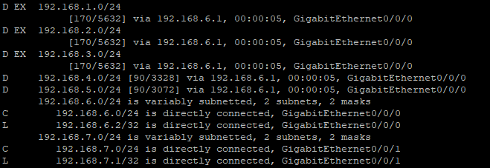

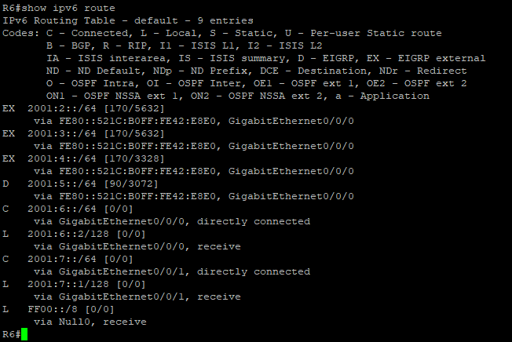

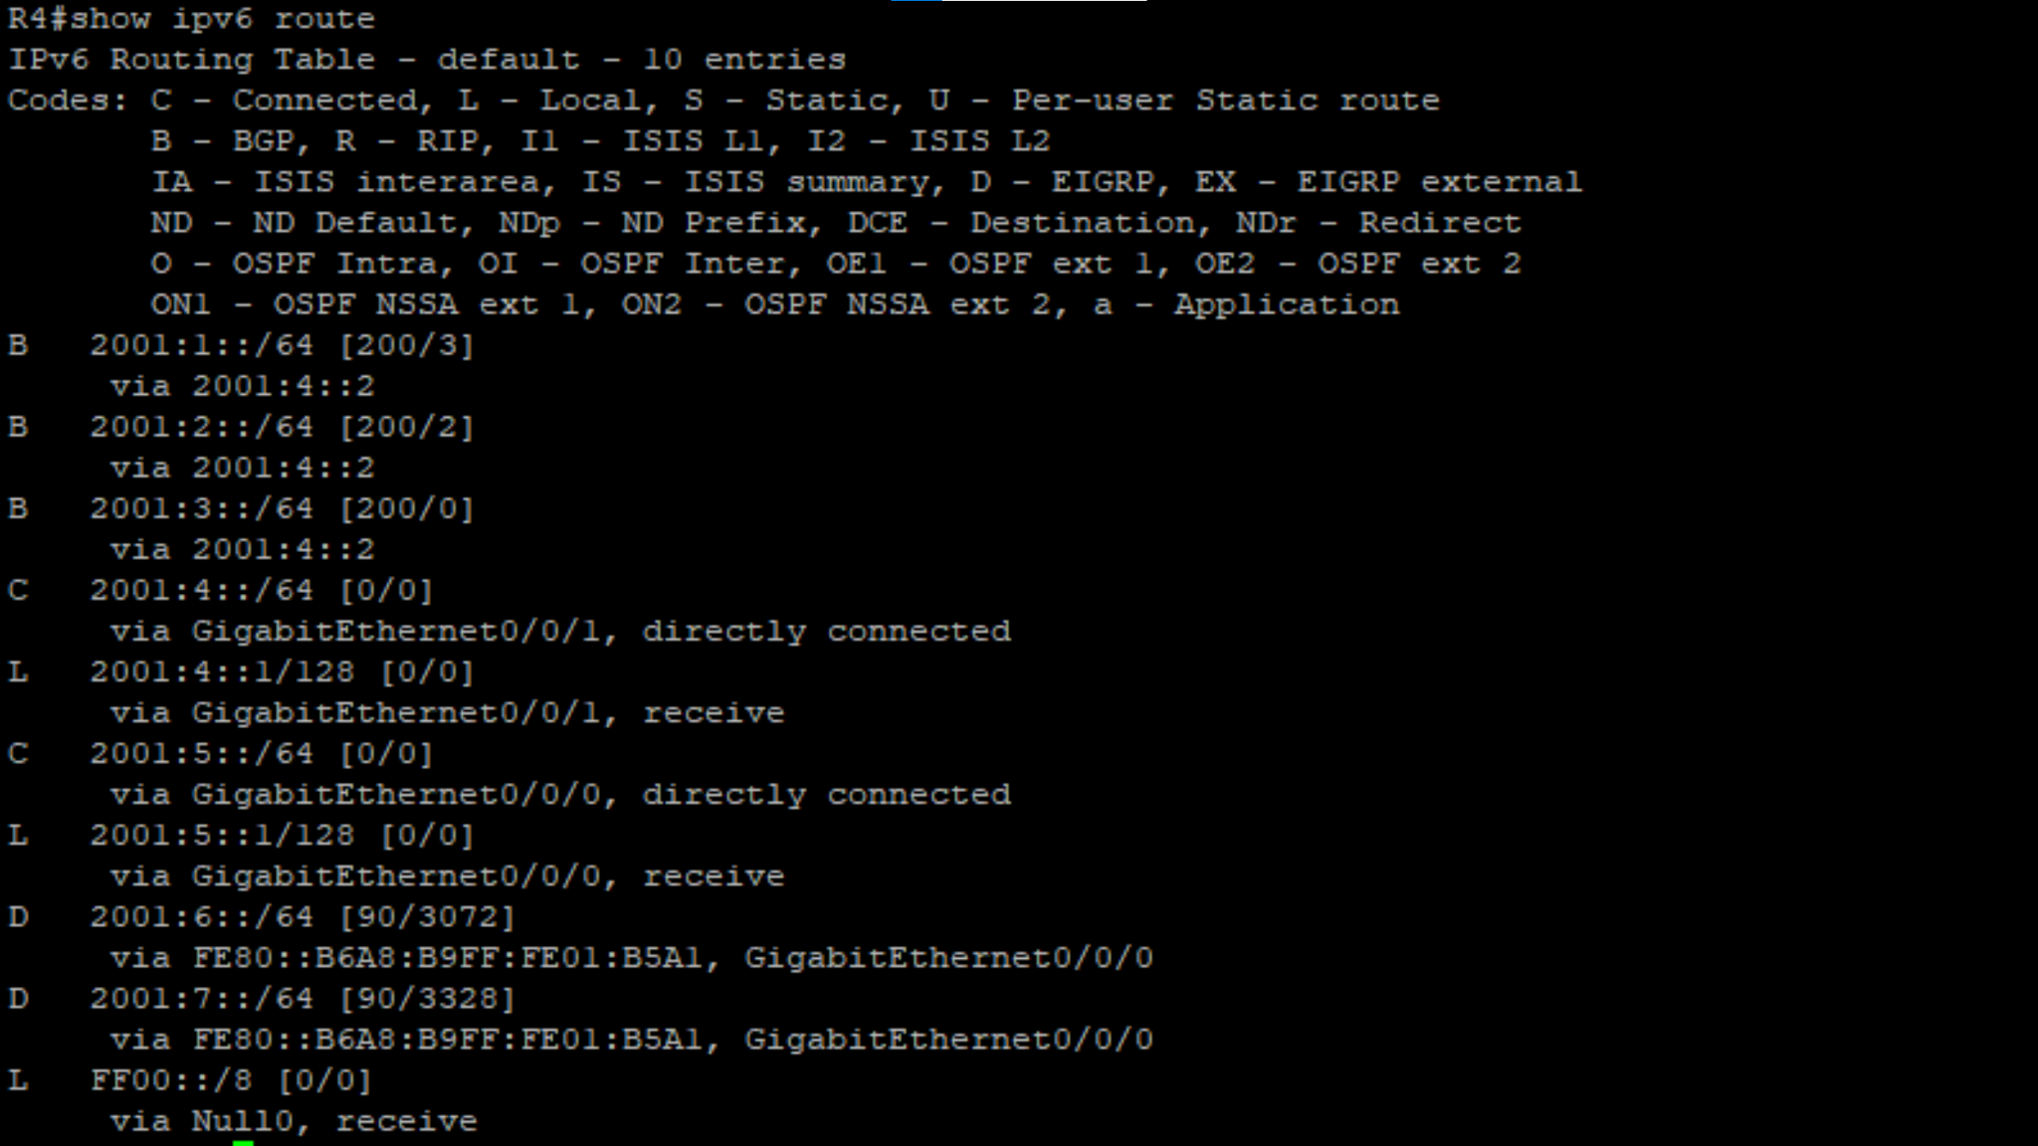

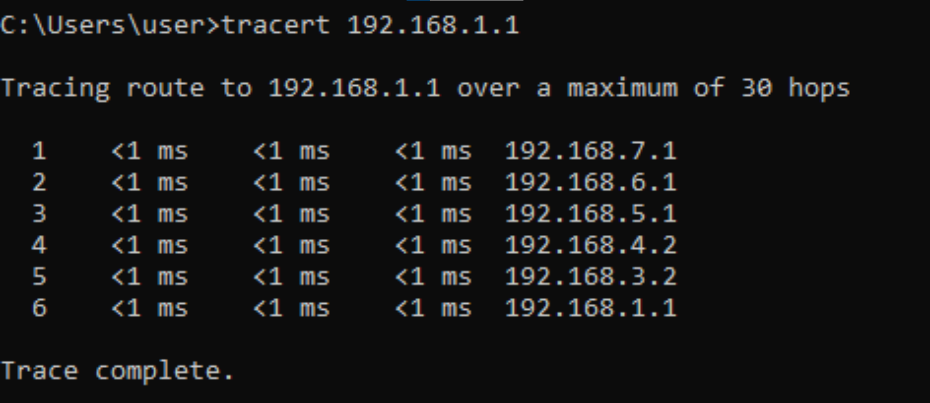  
*Problems:*

One problem we had was that on our original rack router 5 had an outdated operating system, so it couldn’t communicate with other routers. When we tried to update the operating system it wouldn’t take the update and it was almost bricked so we had to switch racks. Another problem we had was that when we searched up how to make EIGRP see the side with OSPF on it but we weren’t sure if we needed to put the router metrics in so we took 2 hours trying to troubleshoot what the problem was when all we had to do was put metrics.

*Conclusion:*

When BGP is properly configured, it works well, but configuring it can be a challenge. You have to get everything right in both of the routing protocols you are connecting first, then you can start to configure BGP.